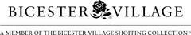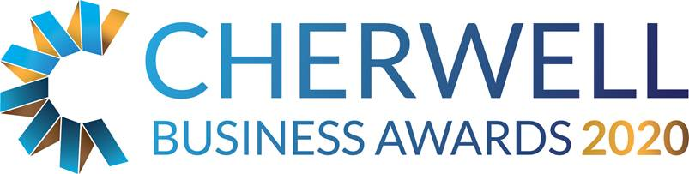

The Bicester Village Retail Award

This category is open to any independent retail business in the Cherwell administrative area meeting the Awards eligibility criteria, regardless of size. The business could be operated entirely online and need not have a bricks and mortar presence, as long as it trades from Cherwell.

THE JUDGES WILL BE LOOKING FOR EVIDENCE OF:
- Your current business performance.
- Your understanding of the market in which you operate.
- Examples of responses to changes in the market.
- Your vision / strategy for future development.
- The stand-out quality that makes the business a potential award winner.

General Business Information
Business Name:
Company No: (if applicable)
Business Address:
Telephone:
Email:
Web address:
Date Trading Started:

Contact Information
Contact Name:
Position:
Telephone:
Email:

Head Office
Do you trade from Cherwell district?  Is the address above your main or trading office? | Yes / No
Do you report to an external / other Head Office? | Yes / No
If you do report to an external head office please give details below

Brief description of the business, including an outline of its products and services.

Describe why your business is successful (give examples/testimonials where available)

How have you reacted to changes in shopping habits?

What challenges do you expect your business to face in the next two years and how are you proposing to overcome them?

What makes your business different from your competitors?

Outline in no more than 250 words why you think you should win the retail award.

Has the organisation achieved any other awards or recognition of sound business practice? (Eg: investors in people, ISO 9001/9002)

Financial Information
(This is kept confidential – figures can be estimate or given as a range)
 | Annual turnover  (£) | Net profit before tax, interest  (£) | Number of employees
Last Year
This Year
Next Year (Forecast)

Additional Comments

What you need to do now
- Please email completed application forms to admin@cherwellbusinessawards.co.uk
- Full applications will only be accepted if received before midnight on Friday 14 February 2020.
- Judges will review entry forms upon receipt and all entrants will be contacted.
- Shortlisted Finalists will be announced by Friday 3rd April 2020.
- Winners will be announced at the Gala Dinner on 15th May 2020 at Heythrop Park, if you would like to book a place at the Awards Dinner please email us on admin@cherwellbusinessawards.co.uk
- Twitter @CherBizAwards - join the conversation #cbas2020.

