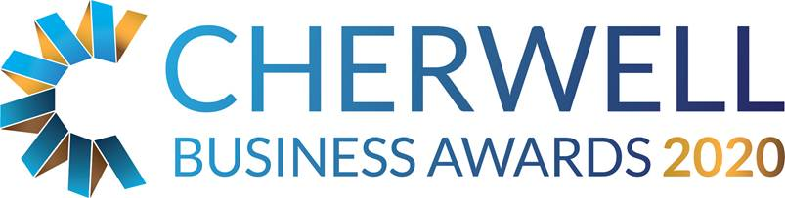

The Ellacotts Business Person of the Year Award

This category is open to any business person working at any level within a business based in Cherwell district, who have through their efforts brought financial and/or non-financial benefits to their organisation.

THE JUDGES WILL BE LOOKING FOR EVIDENCE OF HOW THEY:
- Developed and implemented strategic business plans
- Implemented plans to achieve growth and improve profitability
- Actively taken steps to exceed customer expectations
- Raised their organisation’s profile

Please note that entries must be endorsed by a business colleague, partner, or client

General Information
Business Name:
Business Address:
Post Code:
Company No: (if applicable)
Web address:
Name of person entering:
Position:
Telephone:
E-Mail Address:

Head Office
Do you trade from Cherwell district?  Is the address above your main or trading office? | Yes / No
Do you report to an external / other Head Office? | Yes / No
If you do report to an external head office please give details below

Brief description of your business
Brief description of the business, including an outline of its products or services

Please provide a brief description of the person’s key responsibilities within the business.

What has the person done to merit this Award?

How has the business benefited by this?

What evidence can you supply to prove enduring financial or non-financial benefits to the organisation?

Has this person received any recognition within the organisation for his/her efforts? (e.g. promotion, company commendation)

Has this person received any recognition from outside the organisation for his/her efforts? (e.g. written customer compliments)

Who endorses these achievements?
Name:

Job Title:

Organisation:

What is your view?

Additional Comments

What you need to do now
- Please email completed application forms to admin@cherwellbusinessawards.co.uk
- Full applications will only be accepted if received before midnight on Friday 14 February 2020.
- Judges will review entry forms upon receipt and all entrants will be contacted.
- Shortlisted Finalists will be announced by Friday 3rd April 2020.
- Winners will be announced at the Gala Dinner on 15th May 2020 at Heythrop Park, if you would like to book a place at the Awards Dinner please email us on admin@cherwellbusinessawards.co.uk
- Twitter @CherBizAwards - join the conversation #cbas2020.

