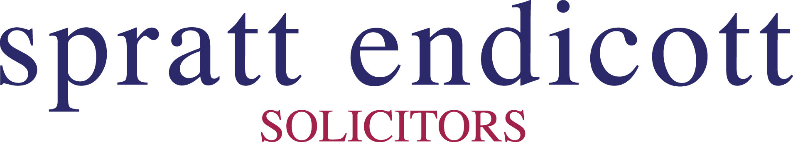
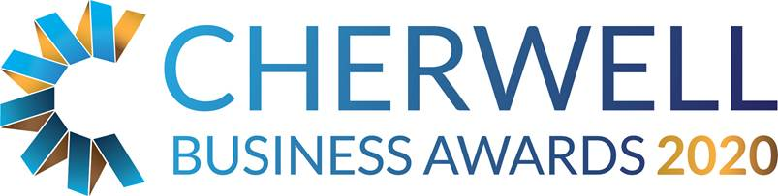

The Spratt Endicott Established Business Award

This category is open to any business based in the Cherwell district that has been trading for more than 7 years.

THE JUDGES WILL BE LOOKING FOR EVIDENCE OF:
- Business growth
- A commitment to the local community including local job creation
- A written business plan demonstrating strategy and vision for the next 3-5 years
- Proven success and achievement during the past 12 months
- Management with the ability to drive the business forward
- A genuine commitment to staff

General Business Information
Business Name:
Company No: (if applic)
Business Address:
Telephone:
Email:
Web address:
Date Trading Started:

Contact Information
Contact Name:
Position:
Telephone:
Email:

Head Office
Do you trade from Cherwell district?  Is the address above your main or trading office? | Yes / No
Do you report to an external / other Head Office? | Yes / No
If you do report to an external head office please give details below

Brief description of your business
Brief description of the business, including an outline of its products or services

Does the business have a documented business development plan that it is following and modifying?

What process does the business go through to gain a full understanding of its markets and its competitive position?

How has the business identified areas of growth? How does the business plan capitalise upon it?

How is the organisation investing in and developing its staff?

What are the future plans of the business? If you have a business plan prepared for 2020, you may wish to send this onto us to support your application.

How do you intend to achieve these plans?

Has the organisation achieved any other Awards or recognition of sound business practice? (e.g. Investors in People, ISO 9001/9002)

Financial Information
(This is kept confidential – figures can be estimate or given as a range)
 | Annual turnover  (£) | Net profit before tax, interest  (£) | Number of employees
Last year
This year
Next year
Forecast

Additional Comments

What you need to do now
- Please email completed application forms to admin@cherwellbusinessawards.co.uk
- Full applications will only be accepted if received before midnight on Friday 14 February 2020.
- Judges will review entry forms upon receipt and all entrants will be contacted.
- Shortlisted Finalists will be announced by Friday 3rd April 2020.
- Winners will be announced at the Gala Dinner on 15th May 2020 at Heythrop Park, if you would like to book a place at the Awards Dinner please email us on admin@cherwellbusinessawards.co.uk
- Twitter @CherBizAwards - join the conversation #cbas2020.

