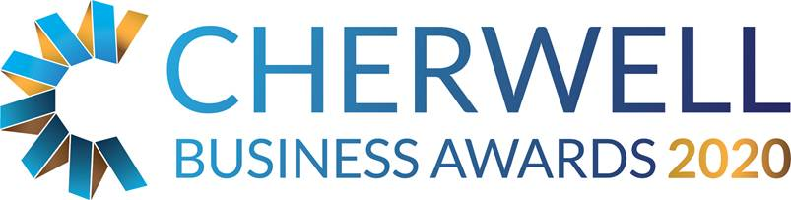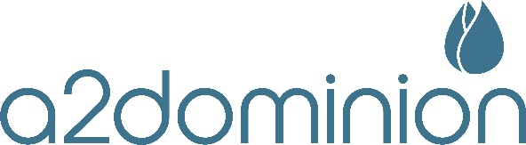

The A2 Dominion Sustainable Award

This category is open to any business in the Cherwell District that can demonstrate that they have practices which promote and support the protection and/or improvement of the environment embedded within their business or are delivering a product or service to customers with sustainable principles at its core. Any organisation, irrespective of size or industry sector can apply.

Judges will be looking for evidence of continuing waste or emission reduction programmes, employees who embrace consideration for the environment within their daily work, and management support for sustainability initiatives within the business and the wider community, or innovative products or services that are designed with a more sustainable future in mind.

THE JUDGES WILL BE LOOKING FOR EVIDENCE OF:
- Waste reduction / efficiency: identifiable reductions in business waste sent to landfill and / or increases in waste sent for recycling; increased use of recycled materials within the business; increased use of raw materials from sustainable sources. Reductions in water or energy usage for a given output.
- Emissions reduction: progress towards zero or lower carbon emission operations.
- Innovation: creative ideas for implementing the above and sustainability more generally within the business without impacting on business efficiency or profitability or an innovative product or service that champions a more sustainable future
- Embedded business narrative: management and support for sustainability initiatives within the business and wider community and employees able to demonstrate about how they have embraced these ideas within their work.
- A 2 year business plan: in support of the companies sustainability ethos or service/product delivery

General Business Information
Business Name:
Company No: (if applicable)
Business Address:
Telephone:
Email:
Web address:
Date Trading Started:

Contact Information
Contact Name:
Position:
Telephone:
Email:

Head Office
Do you trade from Oxfordshire?  Is the address above your main or trading office? |  | Yes / No
Do you report to an external / other Head Office? |  | Yes / No
If you do report to an external head office please give details below:

Brief description of your business
Brief description of the business, including an outline of its products or services

Evidence

Waste reduction / efficiency
What steps has your organisation taken to reduce business waste sent to landfill and / or increases the proportion of waste sent for recycling? Is there evidence of increased use of recycled materials within the business and / increased use of raw materials from sustainable sources? Can you point to reductions in water or energy usage for a given output?

Emissions reduction
What progress is there within your organisation towards zero or lower carbon emission operations?

Business Innovation
Are there innovative and creative ideas used within your organisation to implement waste or emission reduction programmes? How did you generate these ideas and move to adopt them?
Product or Service Innovation
Does your business provide any innovative products or services that are designed with a more sustainable future in mind? How and where have these products or services been designed and delivered?

Embedded Green Practices
Please give examples of how green practices are integrated in your daily operations?

Anything else?
Is there anything else that you would like to tell us? Think about relevant policies, accreditations or other achievements

Financial Information over three years
(This is kept confidential – figures can be estimate or given as a range)
 | 2018 | 2019 | 2020  Forecast
Annual T/O | £ | £ | £
Net profit before tax, interest | £ | £ | £
Number of employees

Additional Comments

What you need to do now
- Please email completed application forms to admin@cherwellbusinessawards.co.uk
- Full applications will only be accepted if received before midnight on Friday 14 February 2020.
- Judges will review entry forms upon receipt and all entrants will be contacted.
- Shortlisted Finalists will be announced by Friday 3rd April 2020.
- Winners will be announced at the Gala Dinner on 15th May 2020 at Heythrop Park, if you would like to book a place at the Awards Dinner please email us on admin@cherwellbusinessawards.co.uk
- Twitter @CherBizAwards - join the conversation #cbas2020.

