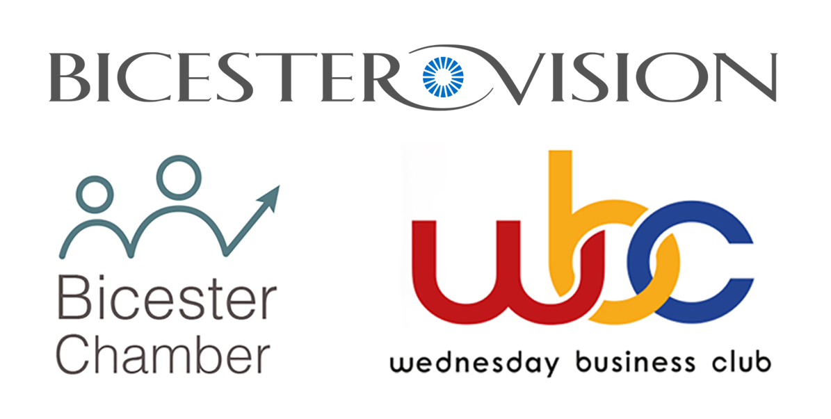
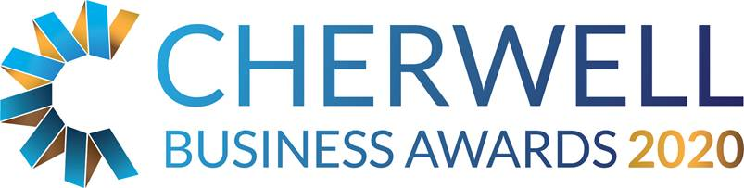

The Bicester Vision, Bicester Chamber and Wednesday Business Club Micro Business Award

This category is open to any business based in Cherwell district with less than 5 staff and started trading after 1st January 2017. It also includes sole traders.

THE JUDGES WILL BE LOOKING FOR EVIDENCE OF:

How you promote or market your business

How you overcome barriers to growth

Business performance that is sustainable in the long term

Why your business is impressive compared to competitors and peers

General Business Information
Business Name:
Company No: (if applic)
Business Address:
Telephone:
Email:
Web address:
Date Trading Started:

Contact Information
Contact Name:
Position:
Telephone:
Email:

Head Office
Do you trade from Cherwell district?  Is the address above your main or trading office? | Yes / No
Do you report to an external / other Head Office? | Yes / No
If you do report to an external head office please give details below

Brief description of your business
Brief description of the business, including an outline of its products or services

Describe why your business is successful?

What issues have you faced and how have you overcome these obstacles?

How do you market your products or services?

Describe your plans for the future:

What makes your business different from your competitors?

Outline in no more than 250 words why you think you should win the Micro Business Award:

Has the organisation achieved any other Awards or recognition of sound business practice? (e.g. Investors in People, ISO 9001/9002)

Financial Information
(This is kept confidential – figures can be estimate or given as a range)
 | Annual turnover  (£) | Net profit before tax, interest  (£) | Number of employees
Last year
This year
Next year
Forecast

Additional Comments

What you need to do now
- Please email completed application forms to admin@cherwellbusinessawards.co.uk
- Full applications will only be accepted if received before midnight on Friday 14 February 2020.
- Judges will review entry forms upon receipt and all entrants will be contacted.
- Shortlisted Finalists will be announced by Friday 3rd April 2020.
- Winners will be announced at the Gala Dinner on 15th May 2020 at Heythrop Park, if you would like to book a place at the Awards Dinner please email us on admin@cherwellbusinessawards.co.uk
- Twitter @CherBizAwards - join the conversation #cbas2020.

